**LEBANESE AMERICAN UNIVERSITY**

**USAID – HIGHER EDUCATION SCHOLARSHIP PROGRAM**

**HES - Volunteering Program Verification Form**

This form is to be used to document volunteering hours. If a student volunteers for multiple organizations, a separate form must be used for each organization. **This form must be turned in by the 28th of each month, the latest.**

I certify that the scholar Alaa Modhi Al Ibrahim completed a total of 6 hours of service at Life Sculptor.

The hours were completed hours as per the below:

Hours # 6 (date) _30/09 – 5/10_ (initials of supervisor) __A.K.___

Hours # 0 (date) _7/10 – 11/10_ (initials of supervisor) __A.K.___

Hours # 0 date) _14/10 – 18/10 (initials of supervisor) __A.K.___

Hours # 0 date) _21/10 -25/10 (initials of supervisor) __A.K.___

Brief description of the activities the scholar performed or participated in:

I conducted research on the impact of globalization on local cultures, focusing on key points such as the definition and overview of globalization, positive effects of globalization on local cultures, challenges posed by globalization to cultural identity, the role of technology in cultural exchange, and case studies of globalization affecting specific cultures. Additionally, I explored strategies for preserving local cultures amidst globalization, future trends in the relationship between globalization and culture, the importance of cultural tourism in promoting local heritage, and the role of education in understanding globalization. After completing the research task, I prepared a PowerPoint presentation summarizing the findings, compiled 12 tips to enhance social media strategies for promoting local cultures in a globalized world, and created a list of 10 potential workshop titles for the Women’s Wellness Center (WWC) department.

Written feedback about the scholar’s performance:

Alaa showcases strong analytical thinking and research skills, especially in examining the complex relationship between globalization and local cultures. Her ability to present both the positive and challenging aspects of globalization reflects her critical thinking. Additionally, Alaa shows creativity and strategic thinking in exploring ways to preserve cultural identity, which highlights her adaptability and growing problem-solving skills.

Please rate the overall performance of the scholar at your organization:

|  |  |  |  |
| --- | --- | --- | --- |
|  | Mastery (5) | Proficient (3) | Emerging (1) |
| **Problem solver** | X |  |  |
| **Engaged & Committed** | X |  |  |
| **Open-minded & multicultural** | X |  |  |

Signature

& stamp

__________________________

_

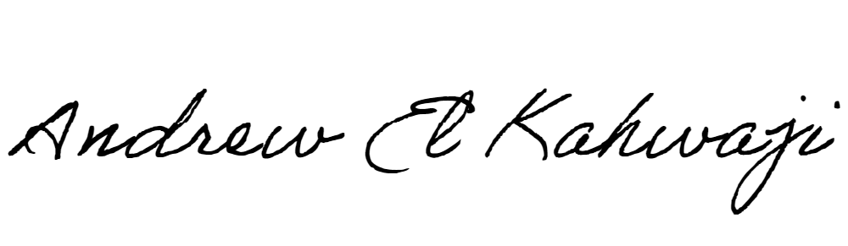

Printed Name _Andrew El Kahwaji_

Date __26/10/2024___

Email __andrew.lifesculptor.coo@gmail.com __

Phone __+961 71 914 378__

**LEBANESE AMERICAN UNIVERSITY**

**USAID – HIGHER EDUCATION SCHOLARSHIP PROGRAM**

